SIMATS ENGINEERING
ASSESSMENT TOOL 4

COURSE NAME: Artificial Intelligence COURSE CODE: CSA17

COURSE OUTCOME COVERED

CO2: Experiment search and game-solving techniques such as Greedy Search, A*, CSP, Minimax, and Alpha-Beta pruning with heuristic functions for solving complex AI problems efficiently. (BL3)

Assessment Tool Weightage: 10%

Duration : 30 Minutes
QUESTIONS: 20 Total Marks:20

Annexure A

MCQ Test

Code of Conduct:

I S.LAKSHITA(192524108) certify that this submission is my original work and that I have adhered to the guidelines specified for this assessment.
I understand that any violation of academic integrity rules will result in disciplinary action.

Signature of the student:

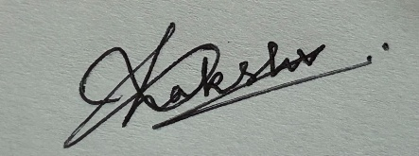

SIMATS ENGINEERING
SAVEETHA INSTITUTE OF MEDICAL AND TECHNICAL SCIENCES
DEPARTMENT OF COMPUTER SCIENCE AND ENGINEERING

CO1 – ASSESSMENT TOOL 3

Descriptive Written Test

COURSE NAME: Artificial Intelligence COURSE CODE: CSA17
QUESTIONS: 2 Duration: 45 Minutes Total Marks: 20

Criteria | Weightage | Q1 (10) | Q2 (10) | Total Marks (20)
Understanding of Concepts | 25% (2.5) | 1.4/2.5 | 1.4/2.5 | 2.8/5
Explanation | 25% (2.5) | 1.4/2.5 | 1.4/2.5 | 2.8/5
Application | 20% (2) | 1.12/2 | 1.12/2 | 2.24/4
Organization | 15% (1.5) | 0.84/1.5 | 0.84/1.5 | 1.68/3
Accuracy | 10% (1) | 0.56/1 | 0.56/1 | 1.12/2
Clarity | 5% (0.5) | 0.28/0.5 | 0.28/0.5 | 0.56/1
Total per Question | 10 Marks | 5.6/10 | 5.6/10 | 11.2/20

